ĐỀ 2 AGILE SCRUM

**Request 1**

**PO- product owner: - External stakeholder , Accountable for the whole system , responsibility for defining requirement, responsibility for defining scope for each sprint and each scrum team**

Scrum master :Internal A Scrum Master chiefly acts as a coach and facilitator to the Scrum Team . He helps the team to assign user stories with top priority into sprints

BA: bridges the gap between external stakeholders and the development team, interpreting business requirements into understandable development tasks to match a final software product with the expected business value

Developer team : internal stakeholder , He writes, debugs and executes the source code of a software application.

Tester team : Internal stakeholder. The role of a tester is to test out products for bug and provide reports to the project teams about any issues or improvements that the product may require

**Request 2 :** User stories in product backlog

As a *role* , i want to ... so that...

**User story detail :As a team member , I want to log-in through/via my email account in order to safe time while logging in with no need to fill in the password**

**User story detail: As a project manager i want to create and update the WBS and inform the WBS to stakeholder so as to manage and share WBS**

**Acceptance Criteria: - WBS can be managed by version , can be deligated to sub-project manager – (AC về mặt business)**

* **A task in WBS can be dragged and dropped (AC về mặt function)**

Cách trình bày khi thi trên EOS

User story title 1 : more option to log-in

User story detail 1 : As a team member , I want to log-in through/via my email account in order to safe time while logging in with no need to fill in the password

Acceptance criteria 1 : - When user register to the system, the system will automatically recommend the option “Register by email “. With the user that registered with email, they can log – in via email to safe time and do not have to enter password

User story title 2 :

User story detail 2 :

Acceptance criteria 2 :

**BÀI MẪU CHO RACI CHART ĐỀ AGILE**

Request 2

**Scrum**

**Raci chart**

|  | Scrum Master | BA | Developer | Tester | PO -product owner |
| --- | --- | --- | --- | --- | --- |
| Create product backlog | C | C | C | I | R/A |
| Create Sprint backlog | R | C | C | C | A |
| Create BD | C | R/A | C | I | A |
| Implement coding | C | C | R/A | C | A |
| Perform testing | C | I | C | R/A | A |

**RACI CHART - MODEL WATER FALL, ITERATIVE INCREMENTAL, V-MODEL**

**Request 2**

**Iterative**

Raci - Responsibility assignment matrix – R -A -C -I

|  | PM- | BA – | Developer | Tester | Customer |
| --- | --- | --- | --- | --- | --- |
| Create project charter | R | C | C | C | C |
| Create SRS | A | R | C | C | C/R |
| Create BD, | A | R | C | I/C | C |
| Create DD | A | C | R(senior) | I/C | I |
| Implement coding | A | C | R | C | I |
| Create test scenario/test case | A | R | C | R | C |
| Perform testing | A | I | C | R | I |

**Vd trình bày khi thi EOS**

RACI chart :

Create project charter PM(R) , BA(C) , Dev(C), Tester (C), Customer (C)

Create SRS: PM(A), BA(R), Dev(C), Tester (C), Customer (C/R)

Create BD: PM(A) , BA(R) , Dev(C), Tester (I/C), Customer (C)

Create DD: PM(A) , BA(C) , Dev(R), Tester (I/C), Customer (I)

Implement coding : PM(A) , BA(C) , Dev(R), Tester (C), Customer (I)

Create test scenario/ test case: PM(A) , BA(R) , Dev(C), Tester (R), Customer(C)

Perform testing: PM(A) , BA(I) , Dev(C), Tester (R), Customer(I)

**Request 3 -** Project Management System – level 1

1. Project Initiation – level 2

1.1 Identify stakeholders and their requirements– level 3

1.2 Create project charter– level 3

1.2.1 Define project scope and objectives – level 4

1.2.2 Determine resource needed - level 4

1.3 Define project team roles and responsibilities– level 3

1.4 Conduct project kickoff meeting– level 3

2. Sprint 0: Planning and Setup– level 2

2.2 Create product backlog and prioritize features– level 3

2.3 Define sprint cycles and timelines– level 3

2.4 Set up development environment and tools– level 3

2.5 Define Definition of Done (DoD) – level 3

2.6 Develop release plan– level 3

3. Sprint 1– level 2

3.1 Sprint planning meeting– level 3

3.2 Develop user stories for sprint – level 3

3.3 Define sprint backlog and tasks– level 3

3.4 Develop software architecture and design– level 3

3.5 Implement core functionalities of PMS– level 3

3.6 Conduct daily scrum meetings– level 3

3.7 Test and validate sprint deliverables– level 3

3.8 Conduct sprint review and retrospective– level 3

4. Sprint 2– level 2

4.1 Sprint planning meeting– level 3

4.2 Develop user stories for sprint– level 3

4.3 Define sprint backlog and tasks– level 3

4.4 Implement additional functionalities of PMS– level 3

4.5 Conduct daily scrum meetings– level 3

4.6 Test and validate sprint deliverables– level 3

4.7 Conduct sprint review and retrospective– level 3

5. Sprint 3– level 2

5.1 Sprint planning meeting– level 3

5.2 Develop user stories for sprint– level 3

5.3 Define sprint backlog and tasks– level 3

5.4 Implement remaining functionalities of PMS– level 3

5.5 Conduct daily scrum meetings– level 3

5.6 Test and validate sprint deliverables– level 3

5.7 Conduct sprint review and retrospective– level 3

6. Sprint 4: Release and Deployment– level 2

6.1 Conduct final sprint planning meeting– level 3

6.2 Test and validate final release– level 3

6.3 Conduct final sprint review and retrospective– level 3

6.4 Deploy DTS to production environment– level 3

6.5 Conduct post-release testing and monitoring– level 3

6.6 Close out project– level 3

Request 4 – Network diagram







Determine / Define the duration of this project / Define the minimum duration to complete all the deliverable

path 1 : Start -> A -> B -> C-> G-> End 4+3+2+6 = 15weeks

path 2 : Start ->D -> B -> C-> G-> End 5+3+2+6 = 16weeks

path 3 : Start -> D -> E -> F-> G-> End 5+4+2+6 = 17weeks

path 4 : Start -> D -> H -> I -> End 5+5+9 = 19weeks -> critical path

19week is the duration of the project

duration of the project is the longest path

Explain: To reduce the overall project schedule by 3 weeks, we will focus on reducing the amount in the critical path. But after being reduced to 16 weeks , there is 1 more path that is exceeding this number which is path 3 – 17 weeks. On the other hand, path 3 and critical path both have task D . Obviously , we will have something to do with task D under crashing method

Crashing: In this method , we can try to shorten the duration of some of the critical path activities by adding additional resources or working overtime.

Solution1 : we can add more workers to task D to complete it earlier than 3 weeks

Solution 2: we can force the team to work overtime in task D so that it can be completed earlier than 3 weeks.

Solution 3 : reward the team if they can complete task D earlier than 3 weeks

* Crashing will increase cost .

Fask tracking : - song song

Put the task D overlap the task E and H , in detail, after starting the D for 2 week, we will consider to start the task E and H

BÀI NETWORK DIAGRAM – PMG201C :

Đề bài :

Bài chữa :

**TH1 : early start = 1 , 1 based planning project**

**EF = ES + duration – 1**

**ES của task sau = EF của task trước + 1**

predecessor activity 







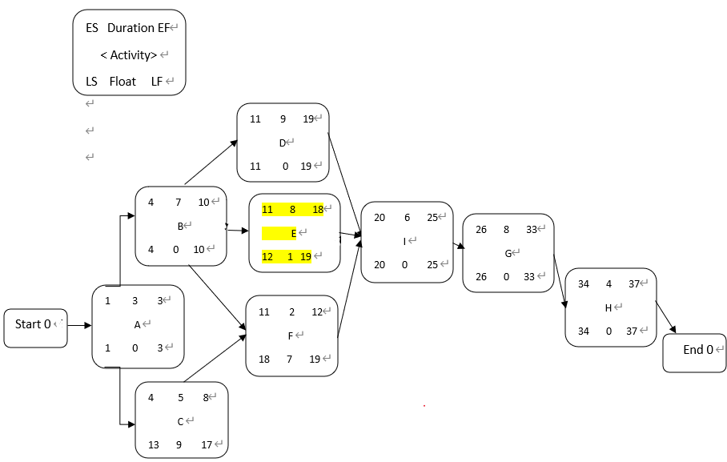

**Path 1 Start -> A -> B-> D -> I->G-> H -> End total 37 weeks**

Path 2 Start -> A->B -> E->I->G->H-> End total 36days

Path 3 Start ->A ->B -> F ->I ->G ->H -> End total 30 days

Path 4 Start -> A->C->F->I->G->H->End total 28days

Critical path is the path that contains all the critical task (float =0)

So the critical path is : Path 1: Start -> A -> B-> D -> I->G-> H -> End

And the project duration is 37 days

Critical path method

**TH2: ES = 0 , 0 based planning**

**EF = ES + duration**

**ES task sau = EF task trước**

**Path 1 Start -> A -> B-> D -> I->G-> H -> End total 37 days**

Path 2 Start -> A->B -> E->I->G->H-> End total 36days

Path 3 Start ->A ->B -> F ->I ->G ->H -> End total 30 days

Path 4 Start -> A->C->F->I->G->H->End total 28days

* Forward pass -> tính được ES, EF của từng đầu việc , project duration
* Backward pass -> tính được LF, LS, Float

ES early start – thời gian sớm nhất để bắt đầu 1 task

EF early finish – thời gian sớm nhất để kết thúc 1 việc

LS late start – thời gian muộn nhất để bắt đầu 1 việc/ task

LF late finish – thời gian muộn nhất để kết thúc 1 việc

**Request 3: I will apply the Crashing method: ->this method will increase cost**

Solution 1 - Recruit more people to join project to complete task G earlier than 5 weeks

Solution 2 Force team to work overtime on task G to complete it earlier than 5 weeks

Explanation:

If you want to shorten the project time by 5 weeks, you need to shorten the time of a task on the critical path, but now 10weeks have passed (the end of time for task A, task B and project have been in task D ) so we have a way to shorten the time in tasks G or I or H. The appropriate choice is left with task G with duration of 8 weeks because a task with a duration of 8 weeks should be prioritized to shorten the time over a task with a duration of 4 weeks or 6 weeks. After task G’s duration had been shorten , now the new project duration is 32weeks

Method 2 : we will apply fast tracking methodology

Put the task I overlap the task G in order to execute 2 task in a parallel approach . In detail, after start task I 1 weeks, we begin to start doing task H right away .